REMO-HSE delivers the 10,000th high-voltage module MSR-S-60N30-2m-N2 for electrostatic fine dust filters

Rattiszell, 2022 -07-04

The module is particularly in demand for use in fine dust filters for wood chip heating systems and wood combustion plants. The anniversary copy went to Austria.

REMO-HSE GmbH delivered the 10,000th MSR-S-60N30-2m-N2 high-voltage module on 28 June 2022. REMO-HSE had already conducted tests with customers in 2010, to determine the optimum parameters (e.g., voltage and current range) of a high-voltage supply for electrostatic precipitators in tubular design for reducing particulate matter in woodchip heating systems and small wood-fired heating systems. Among other things, it also turned out that spark monitoring plays a very important role, since the flue gas passes through the filter very inhomogeneously and flows through the filter with fluctuating humidity.
The MSR-S-60N30-2m-N2 module is just one specific model from the MSR series, which includes four power classes as standard (30W, 60W, 90W and 120W), whereby the output voltage in each power class can be up to 30,000V. For all modules, output voltage and current can be adjusted between 0% and 100% of the maximum rated value either via an analogue interface (MSR-S version) or by means of two potentiometers (MSR-P version). Various protective circuits, including spark protection in particular, make the modules very safe.
For larger heating systems, fine dust filters with higher power are required, for which REMO-HSE also has the appropriate high-voltage modules in its range, namely the MMR series with voltages up to 120kV and power ratings up to 750W. Higher outputs can be achieved by connecting the modules in parallel. - Of course, the high-voltage modules of both series are also suitable for electrostatic precipitators, which are used in industrial plants for the separation of aerosols, finest dust particles as well as tar- and oil-containing water-saturated exhaust gases.
The MSR and MMR module series are continuously adapted to new market and customer requirements. In particular, they serve as the basis for high-voltage modules used in X-ray and medical technology.
Further information on the products and their data sheets can be found on the Internet at https://www.remo-hse.com .

About REMO-HSE
Since its foundation more than 39 years ago, REMO-HSE Hochspannungselektronik GmbH has been dealing with high-voltage technology outside the field of power engineering and realises complete projects from the idea to the product ready for series production at market-driven prices. Because no two applications are alike, the medium-sized company from Rattiszell near Straubing/ Danube in Germany has specialised in the development and production of customised solutions. The products are used, for example, in industrial plants for electrostatic surface coating, in electrostatic precipitators, for ionisation in medical technology, in X-ray and particle beam technology or for pulse forming networks in radar systems. In addition to high-voltage power supplies, REMO-HSE has the appropriate high-voltage measurement technology as well as high-voltage switches, resistors, distributors and cables in its product range.

Images / Image Captions

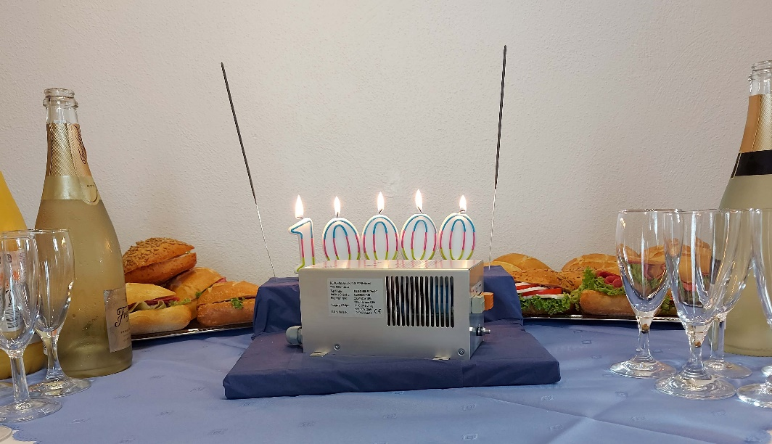
Image 1: The ten-thousandth MSR-S-60N30-2m-N2 module was the focus of a celebration at REMO-HSE.

Contact
Dr. Michael Oleszczuk
REMO-HSE Hochspannungselektronik GmbH
Straubinger Str. 28
94372 Rattiszell
Germany
Tel.: +49 9964 6406 0
E-Mail: info@remo-hse.de

